

PIPELINE ROW PATROL INSPECTION REPORT

**TOTAL**

**(Port Arthur System)**

July 2, 2025

**CONFIDENTIAL DOCUMENTS**

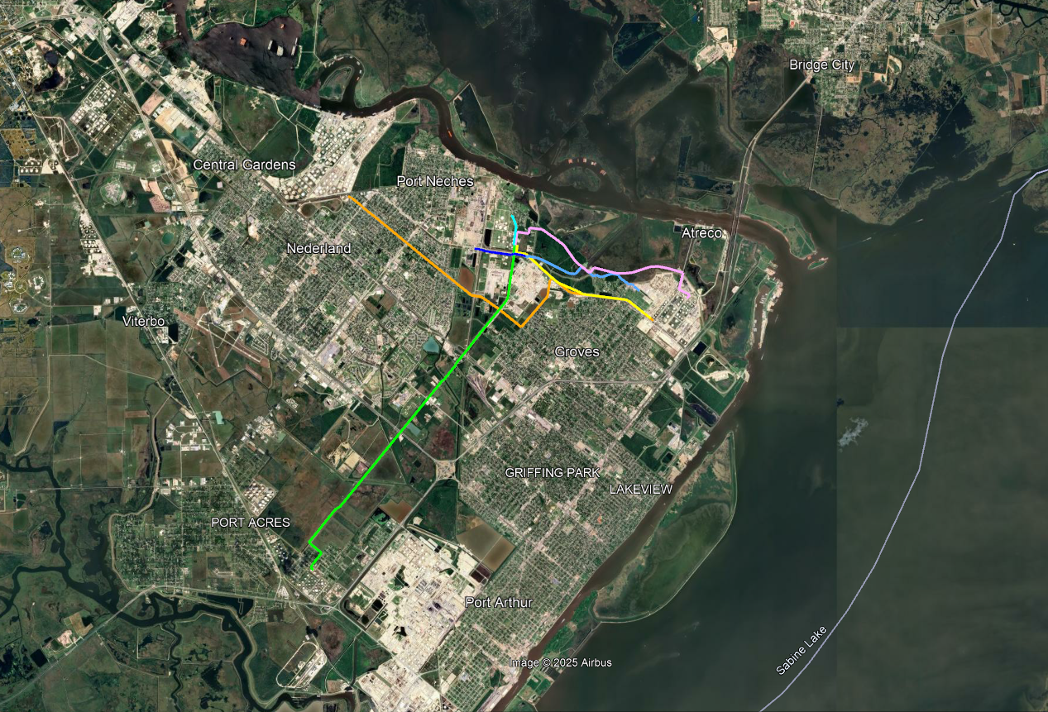

Arch Aerial, LLC

3701 Yale Street

Houston, TX 77018

281.974.5752